MONDAY | TUESDAY | WEDNESDAY | THURSDAY | FRIDAY
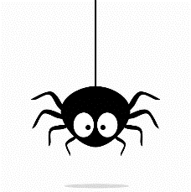  Free play morning | Trip to Liverpool museum  - £3.00 for train  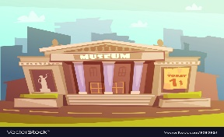  - Packed lunch provided | 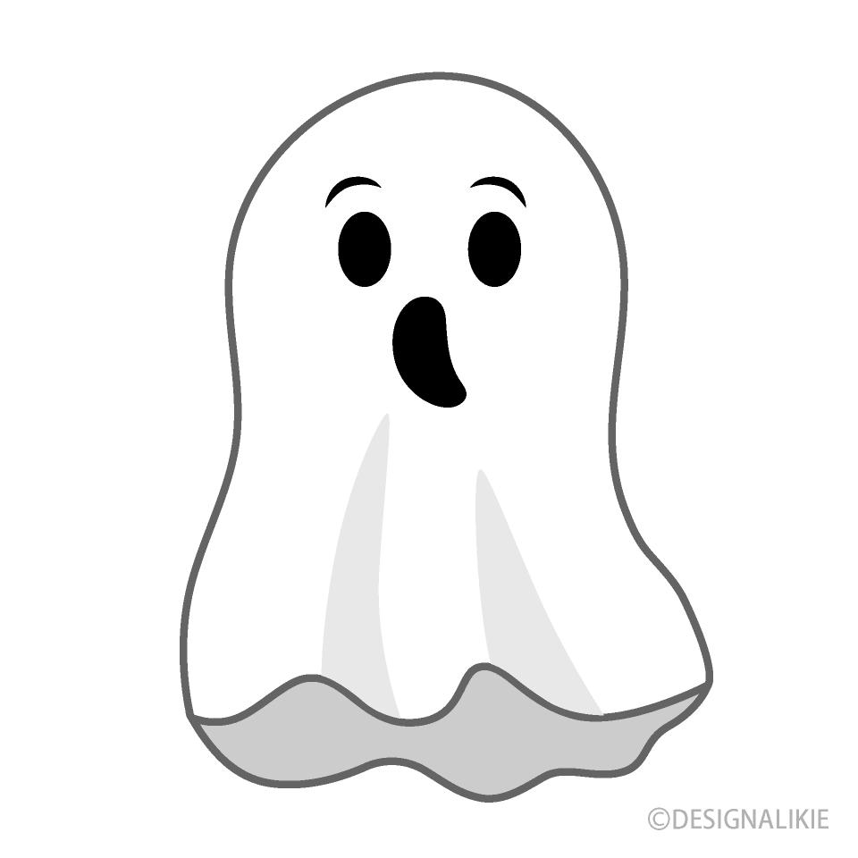  Halloween crafts | Sutton park | Party prep  - Balloons  - Decorations  - Cakes  - Films
Pumpkin carving |  | Halloween treasure hunt  Make Pizzas | Bongos bingo | 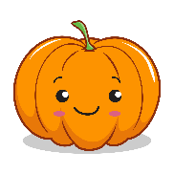  Halloween Party
Child’s choice | Child’s choice | Child’s choice | Child’s choice | Child’s choice

